
Haverford Sports Parents Handbook

LIST OF COACHES:
Cheerleading
Maria DiPaul Safern Varsity
Joanna Turner Kelly Junior Varsity

Cross Country
Laura Clinton Girls
Harry Green Boys
Elizabeth Haglund Assistant
Field Hockey
Christa Taylor Varsity
Polly Ross Junior Varsity
TBA JVB
Football
Joseph Gallagher Varsity
Michael Gentile Assistant
Dan Milewski Assistant
Michael Bright Assistant
Scott Lipschutz Assistant
Elliot Seifert Freshmen
Josh Fidler Freshmen
Golf
Nate Oxman Varsity
Bill Whitney JV
Soccer (Boys)
David Cassanelli Varsity
Andrew Welsh Junior Varsity
Iain McClements Freshmen
Soccer (Girls)
Alexandar Hill Varsity
Nancy McGoldric Junior Varsity
TBA JVB
Tennis (Girls)
Charles Withers Varsity
Kathryn Lisansky Junior Varsity
Volleyball (Girls)
Eric Dahl Varsity
Natalie Rube Junior Varsity
Kathleen Leyden Freshmen
Basketball (Boys)
Keith Heinerichs Varsity
Peter Phillips Junior Varsity
Leon Smith Freshmen
Basketball (Girls)
Lauren Pellicane Varsity
Katie Young Junior Varsity
Nancy McGoldrick Freshmen

Ice Hockey
John Povey Varsity

Swimming (Boys/Girls)
Matt Stewart Varsity
Pat Maguire/Natale Rube Assistant/Diving
Winter Track (Boys)
Aaron Hunter Varsity
Jay Williams Assistant B/G
Winter Track (Girls)
Jim Jensen Varsity
Wrestling
Shawn Fausey Varsity
Jim Knapp/ TBA Junior Varsity
Baseball
Paul Bogosian Varsity
Dave Detweiler Junior Varsity
James Coyne Freshmen
Lacrosse (Boys)
Greg Decina Varsity
Michael Leyden Assistant Varsity
Bryan Arra Junior Varsity
Jack O’Donnell JVB
Lacrosse (Girls)
Nancy McGoldrick Varsity
Kirstin McGoldrick-Sheehe Assistant Varsity
Jessica McClay Junior Varsity
Natale Rube JVB
Softball
Jill Marshall Varsity
TBA Junior Varsity
TBA JVB
Tennis (Boys)
Charles Withers Varsity
Track (Boys)
Aaron Hunter Varsity
Jim Jeffers Assistant
Josh Fidler
Track (Girls)
Jim Jensen Varsity
Jay Williams Assistant
Harry Green Assitant
Volleyball (Boys)
Sam Moyerman Varsity
David Dager Junior Varsity

School District of Haverford Township
High School Credo

As a public comprehensive high school, Haverford High School is committed to the full maturation of all its students. However, unlike other societal institutions, we have as our primary concern the development of our students' intellectual abilities. While the school's curriculum will focus on all aspects of human development necessary for mature adult living, a Haverford diploma will be meaningful and especially symbolic of academic proficiency, knowledge of the rights and duties of citizenship, and the ability to succeed in either higher education or productive employment. Our mission is to insure that all of our graduates achieve their full potential as persons competent to participate and goal interact intelligently in the complex and dynamic society of the 21st century To achieve this we will require all students to master liberal and fine arts, in the natural and social sciences and in mathematics and-technology. Because the next generation will live in a global village, the national, international, and interdisciplinary dimensions of these studies will be emphasized as will those communication skills necessary to live and work effectively with others. All students must demonstrate the ability to read critically, write clearly and speak fluently; and to insure the success of this goal, all courses will require students to use the English language proficiently. A demanding core curriculum requires hard work on the part of the students, but we believe they will achieve as much as we expect of them. To set our expectations lower would be to do our students and our public a disservice. Because both students and the high school must be held accountable for what they do, assessment measures will be used on a regular basis to verify that our high expectations are being met.

A strong faculty is critical to the accomplishment of our purpose; therefore, Haverford is committed to recruit, employ/ and nurture only the most qualified and talented professionals for teaching positions. First and foremost/ our teachers must be enthusiastic about working with and educating adolescents and be experts in the fields they teach. They should know the various pedagogical strategies that produce effective instruction. As professional educators, they must work to continually renew themselves as persons/ teachers, and scholars. Moreover, because complacency leads to mediocrity, the faculty will be encouraged to challenge the status quo; innovation and risk-taking will be supported and doing things in demonstrably better-ways will be rewarded. Realizing also that the school will not be successful without the support of the family and the community, Haverford's mission will be disseminated broadly, and our parents and citizens will be encouraged to participate actively in the education of our youth. Indeed we believe that a home environment supportive of educational excellence is essential to- the realization of our mission, as is the continued philosophical and financial support of the community.
The support of parents and community must be matched by a commitment by our students to enhancing the public welfare. Therefore -we will require that all students engage in some specific and meaningful service activities in which they can develop and demonstrate their concern for the common good Such activities will promote the full maturity of students as persons who possess both rights- and duties

Finally, the high school must insure that each student is accorded the recognition and respect due all persons of intrinsic worth. Each must be known and cared for as an
individual, and the rules and procedures governing the school must be just and administered equitably. We expect teachers, administrators and all who work with our students to serve as role models and as such to exhibit behavior consistent with the ideals of our democratic society.
The Board of School Directors will assure that Haverford High School is a learning community in which faculty and students exhibit mutual respect that is sustained by a supportive community. In their pursuit of truth and excellent, students and faculty will demonstrate pride in their work and a love of learning.
These beliefs shall be our guiding principles.

Code of Conduct and Sportsmanship
All students shall be guided by the highest standards of integrity and honesty in the classroom, on the practice field, and in competition.
1. Students shall avoid any act tending to promote their own interests at the expense of the dignity of their school.
2. Students shall avoid any act tending to promote their own interests at the expense of the dignity of a fellow student.
3. Students shall not compete unfairly on the practice field, in competition, or in the classroom.
4. Students shall not attempt to malign, directly or indirectly, another student, coach or instructor.
5. Students shall give credit to their fellow players, coaches and sponsors when such credit is deserved.
Students, including athletes, shall dedicate their primary efforts to the goals and interests of their school, sport, activity, teammates and the public.
1. Students shall hold paramount the safety of teammates as well as their opponents.
2. Students shall abide by the rules and regulations of their coaches and sponsors, as well as P.I.A.A., Central Athletic League and Haverford High School.
3. Students athletes shall dedicate their efforts to academic progress for their own benefits as well as their team.
4. Students shall not permit the use of their names in advertising
ventures with any person or firm where such act is a violation of the school or a governing association's rules and regulations.
5. In public statements or in interviews with the press, students and
student athletes shall make statements in a truthful and factual way.
6. Students and student athletes shall not be influenced in their competition by conflicting personal or financial interests.

Physical Examinations for Student Athletes Haverford Township School District Policy
Purpose: The School District of Haverford Township seeks to provide all students who desire to participate in athletic events the safest possible condition for participation. Every child seeking to participate in athletics will therefore be required to submit the results of a physical examination on the approved Pennsylvania Interscholastic Athletic Association's Parent Certificate and the Haverford Township School District Physician's Certificate.
The Pennsylvania Interscholastic Athletic Association permits that a comprehensive pre-participation physical evaluation be certified on a cycle beginning June 1 and ending May 31 of each school year. If the student has an annual physical on file, parents must submit Section 7 of the physical form each season of play. If an injury has occurred during the season of play the student will be required to provide a Physician’s note granting the student permission to be reinstated back into participation.
A student must have a physical examination on file with the school district prior to any participation in an athletic contest or practice session.

Guidelines Such physical examination shall be at the expense of the student(s) or his/her parent(s) or guardian(s). If documentation exists (such as eligibility for reduced or free lunch) that indicates that the required physicals are a financial hardship, the School District will review and assist in payment for medical evaluations required for participation.

The parents/guardians of students who seek to participate in athletics shall be required to complete an information form that provides school officials with additional information on prospective athletes before athletic participation is approved by the school.
Should the Physician's Certificate and/or the Parent Information Form reveal that a child has experienced any physical ailment that places the student's health in jeopardy; the student will be required to have a physical examination to determine if the reported ailments still exist. When the final medical approval is granted and verified by a physician's signature, the child may be cleared for participation/
Participation will be denied if the Physician's Certificate reveals any medical problem experienced by the prospective athlete that might be determined as life or health threatening.
Any athlete who has sustained an injury, or a health problem requiring a physician's care, must receive a medical release from his/her physician before the student may return to athletic participation. The School District, through the appropriate office of the School Principal or his/her designee, may request at any time a second medical evaluation, at the school's expense, if there is doubt regarding the health of a participating student.
Authority The Board directs the Superintendent to ensure that all school system employees and students be made aware of this policy through proper induction, information, and orientation programs. The Board further directs the Superintendent or designee to develop any authorization, assurance, verification, or release forms necessary to implement the intent of the policy.

Impact Testing
IN ADDITION TO THE PHYSICAL, ALL ATHLETES WILL PARTICIPATE IN IMPACT TESTING WHICH WILL HELP DETERMINE WHEN A CONCUSSION IS DIAGNOSED AND WHEN THE ATHLETE IS READY TO RETURN TO PLAY. THE PROGRAM CALLS FOR A BASELINE TEST THAT WILL BE COMPARED TO THE AFTER INJURY TEST TO IDENTIFY THE STUDENT’S READINESS TO PLAY. THIS BASELINE TEST WILL BE ADMINISTERED BY THE TRAINERS DURING THE FIRST PRACTICE WEEK OF THE RESPECTIVE SPORT, AND SHOULD TAKE ABOUT AN HOUR. ALL ATHLETES ARE REQUIRED TO PARTICIPATE UNLESS THEIR PARENT HAS SIGNED AN OPT OUT FORM. FRESHMAN AND JUNIORS AND NEW ATHLETES WILL BE TESTED, KEEPING A CYCLE OF EVERY OTHR YEAR.

Overview and Features of the ImPACT Test
ImPACT (Immediate Post-Concussion Assessment and Cognitive Testing) is the first, most-widely used, and most scientifically validated computerized concussion evaluation system.
Developed in the early 1990's by Drs. Mark Lovell and Joseph Maroon, ImPACT has become a standard tool used in comprehensive clinical management of concussions for athletes of all ages. ImPACT Applications, Inc. was co-founded by Mark Lovell, PhD, Joseph Maroon, MD, and Michael (Micky) Collins, PhD.
Given the inherent difficulties in concussion management, it is important to manage concussions on an individualized basis and to implement baseline testing and/or post-injury neurocognitive testing. This type of concussion assessment can help to objectively evaluate the concussed athlete's post-injury condition and track recovery for safe return to play, thus preventing the cumulative effects of concussion. In fact, neurocognitive testing has recently been called the "cornerstone" of proper concussion management by an international panel of sports medicine experts.
ImPACT is the most widely used computer-based testing program in the world and is implemented effectively across high school, collegiate, and professional levels of sport participation.

Understanding Of Risk Of Concussion and Traumatic Brain Injury
This information sheet is designed to inform parents and students about concussion and traumatic brain injury. If your student exhibits signs or symptoms of a concussion or traumatic brain injury, they shall be removed from participation. The student shall not return until they are evaluated and cleared by a medical professional.

What is a concussion?
A concussion is a brain injury that
- Is caused by a bump, blow or jolt to the head or body
- Can change the way a student’s brain normally works
- Can occur during practices and/or contests in any sport
- Can happen even if a student has not lost consciousness
- Can be serious even if a student has just been “dinged” or “had their bell rung”
All concussions are serious. A concussion can affect a student’s ability to do schoolwork and other activities (such as playing video games, working on a computer, studying, driving or exercising.) Most students with a concussion get better, but it is important to give the concussed student’s brain time to heal.
What are the symptoms of a concussion?
Concussions cannot be seen; however, in a potentially concussed student, one or more of the symptoms listed below may become apparent and/or that the student “doesn’t feel right” soon after, a few days after, or even weeks after the injury.
- Headache or “pressure” in head Feeling sluggish, hazy, foggy, or groggy
- Nausea or vomiting Difficulty paying attention
- Balance problems or dizziness Memory problems
- Double or blurry vision Confusion
- Bothered by light or noise
What should students do if they believe that they or someone else may have a concussion?
- Students feeling any of the symptoms set forth above should immediately tell their Coach and their parents. Also, if they notice any teammate evidencing such symptoms, they should immediately tell their Coach.
- The student should be evaluated. A licensed physician of medicine or osteopathic medicine (MD or DO), sufficiently familiar with current concussion management, should examine the student, determine whether the student has a concussion and determine when the student is cleared to return to participate in interscholastic athletics.
- Concussed students should give themselves time to get better. If a student has sustained a concussion, the student’s brain needs time to heal. While a concussed student’s brain is still healing, that student is much more likely to have another concussion. Repeat concussions can increase the time it takes for an already concussed student to recover and may cause more damage to that student’s brain. Such damage can have long-term consequences. It is important that a concussed student rest and not return to play until the student receives permission from an MD or DO, sufficiently familiar with current concussion management, that the student is symptom-free.
How can students prevent a concussion? Every sport is different, but there are steps students can take to protect themselves.
- Use the proper sports equipment, including personal protective equipment. For equipment to properly protect a student, it must be the right equipment for the sport, position, or activity, work correctly and be the correct size and fit; and used every time the student practices and/or competes
- Follow the Coach’s rules for safety and the rules of the sport
- Practice good sportsmanship at all times
If a student believes they may have a concussion: Don’t hide it. Report it. Take time to recover.
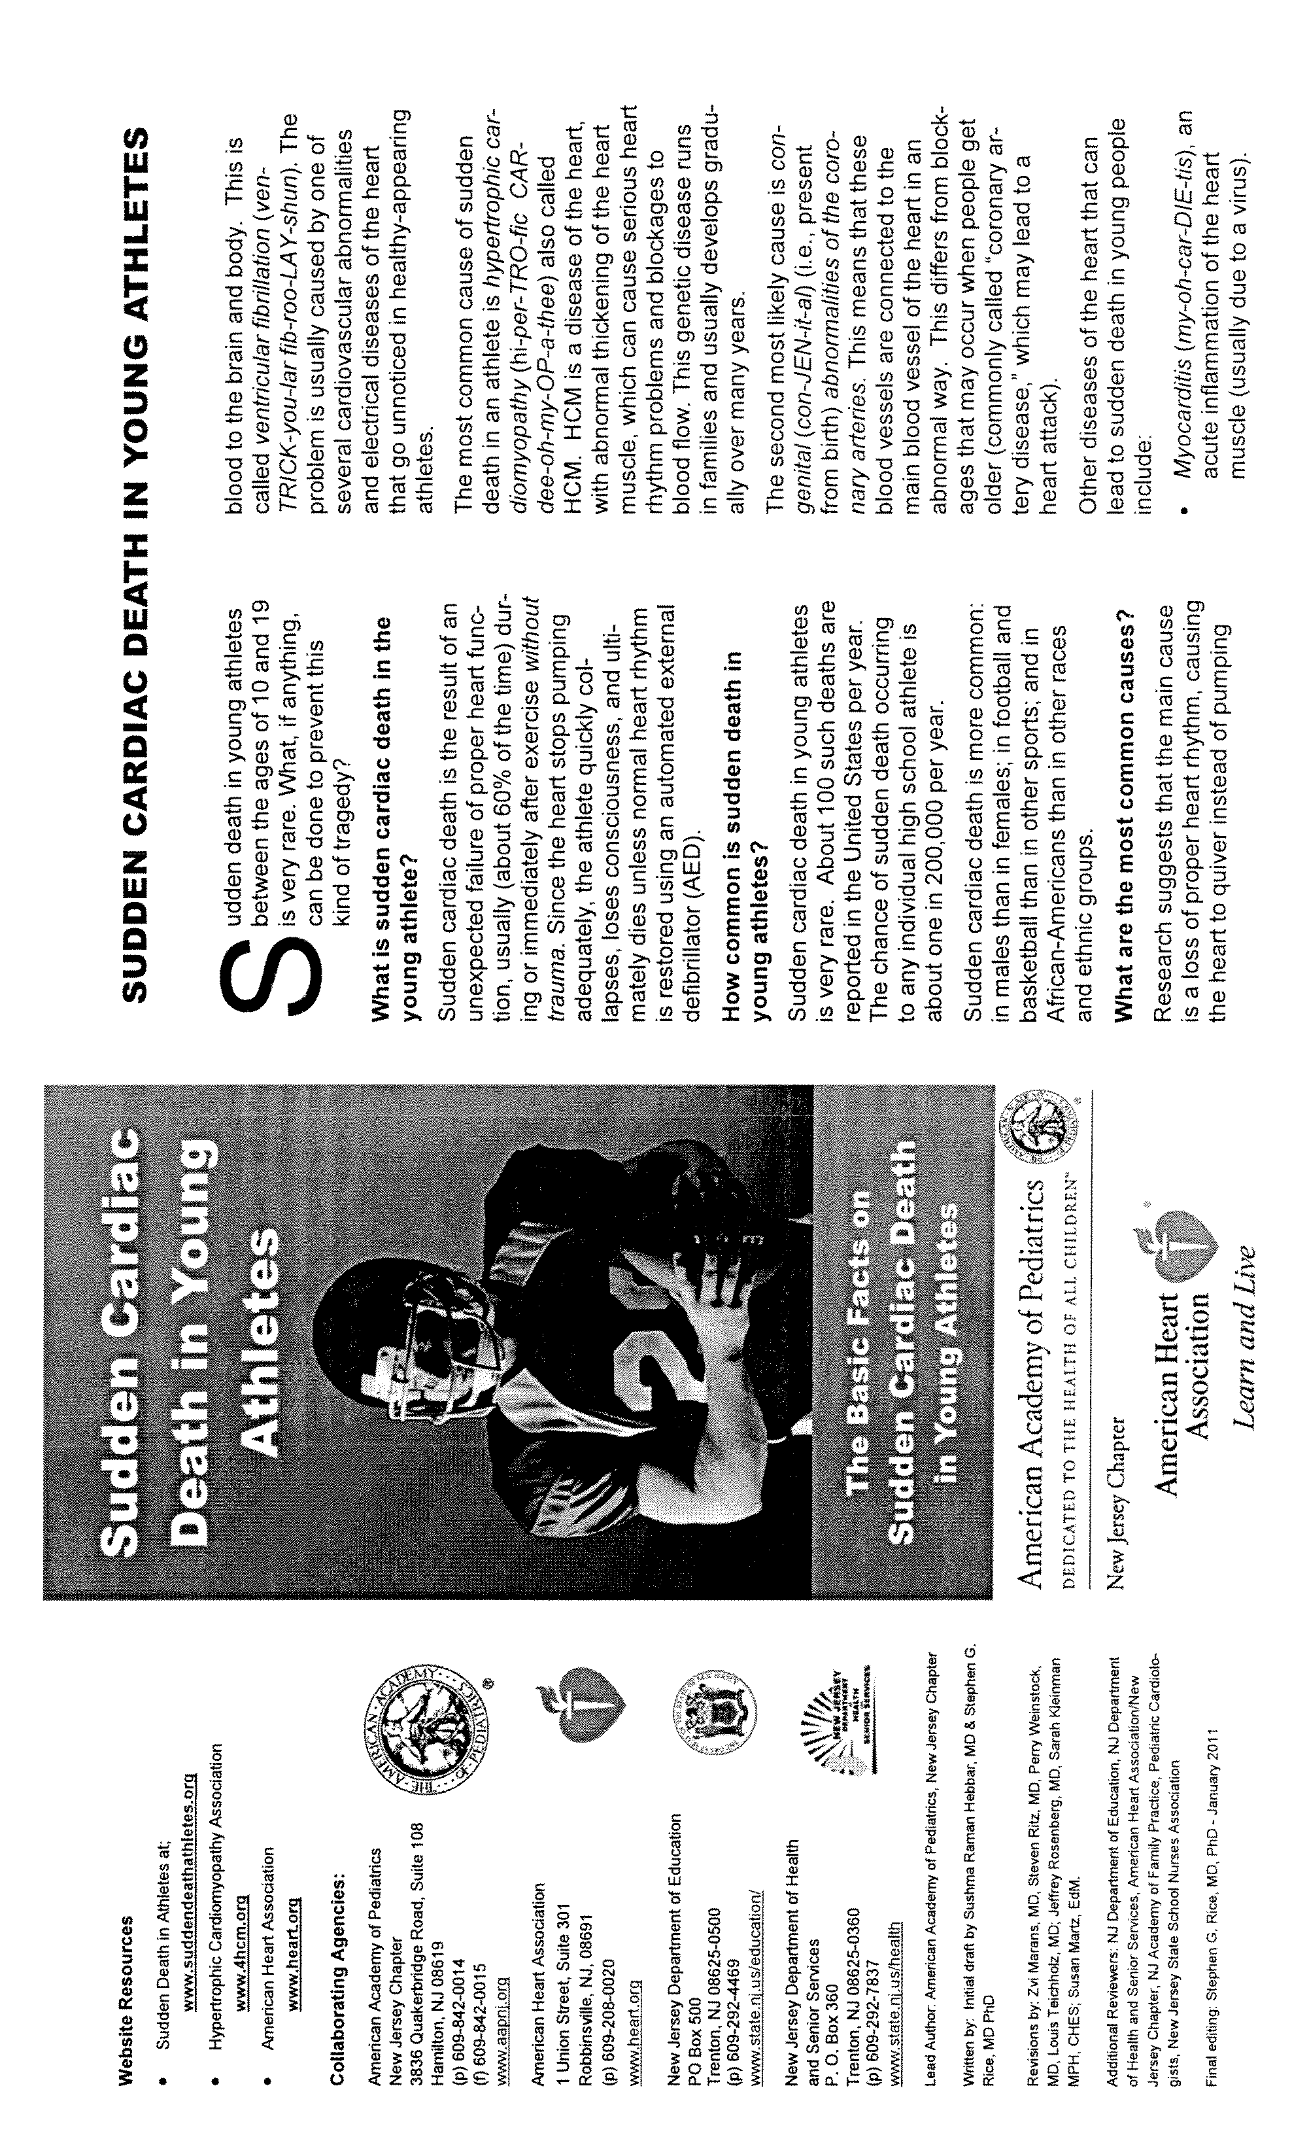

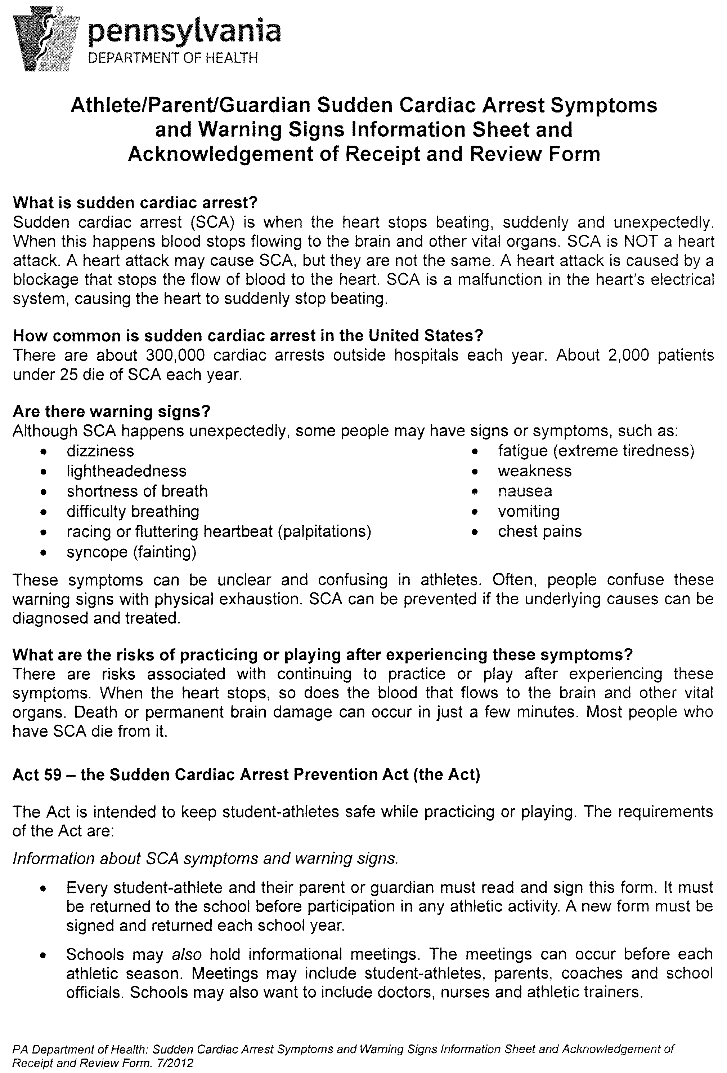
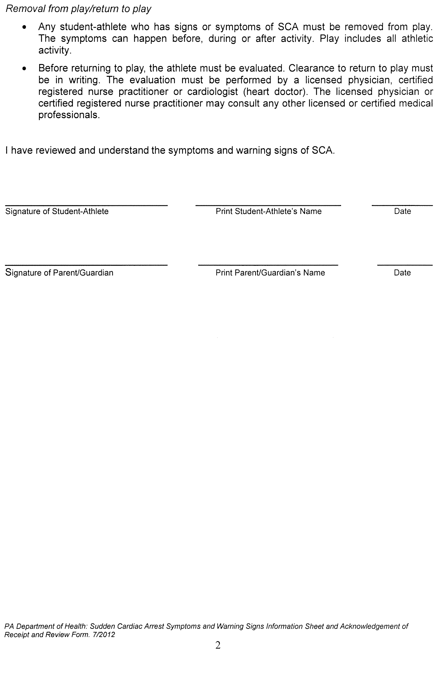
Insurance School District provided Accident Insurance
By decision of the Haverford Township School Board/ players are insured by the district.
The School District makes available a "Student Accident Insurance" policy. Brochures explaining this insurance are available in homerooms when school opens in September. The District strongly recommends all students who participate in athletics elect to purchase this coverage.
If your son/daughter tries out, practices, or participates in a fall sport before school opens and then you purchase the "Student Accident Insurance" on the first or second school day, the coverage is retroactive to the first approved practice date.
If a parent purchases School District Accident Insurance that covers an athletic related injury, it is the parent's responsibility to apply for coverage. If an accident occurs, a claim form should be obtained immediately from the high school office.
What the parent should do in the event of an injury?
1. Family insurance coverage; the parent is responsible.
2. School District provided insurance purchased by a parent.
a. Call the Athletic Office to make sure that a "School District of Haverford Township Accident Report" is on file. This should be done within a seven to 10-day period following the injury.
b. Arrange with the athlete to have the paperwork signed by the proper authorities.
i.. Fill out portion to be completed by parent.
ii. Take form to doctor by the second visit for completion of his
part. DO NOT LEAVE THIS FORM WITH THE DOCTOR.
iii. Attach all bills to claim and mail directly to the insurance company. Any further bills are to be collected and mailed together. DO NOT return bills or claim to school.
iv. If you have any questions concerning the policy please contact the athletic office for contact information

Rules and Regulations for Student Athletes
Introduction
A student athlete is a representative of the Haverford High School community. As a member of this community, each student has a responsibility to understand and live by the established rules of behavior. Participation in High School athletics is an earned opportunity and a special privilege. Violations of policies and regulations may severely restrict a student's participation in athletic competition.
In addition to the P.I.A.A. rules and eligibility requirements, students are expected to read and comply with all other established rules and behavioral expectations. These include team rules, specific high school rules and regulations as determined by the administration, and Haverford School District Policies.
We invite you to visit PIAA.org to review their information.
Team Rules
Establishing team rules and regulations for each sport is the responsibility of the head coach. For example, each coach will articulate expectations regarding team practice and game conduct. Uniform dress code, equipment care, and absence policy are some of the additional areas where individual coaches determine specific rules. It is the student's responsibility to review and acknowledge team rules before joining the team.
High School Rules and Regulations
Each fall, students receive information with regard to Student Expectations. The Student Responsibilities section explains the behavioral expectations for all high school students. Additionally, students should review "Expectations for Student Behavior—Haverford Senior High School." It is each student's responsibility to review and acknowledge high school rules and regulations.

Hazing/ Bullying is not an accepted practice by the Haverford School District and cannot be tolerated or condoned in the athletic program.

The PA Human Relations Commission promotes equal opportunity for all and enforces Pennsylvania's civil rights laws that protect people from unlawful discrimination. As Pennsylvania's civil rights leader, it is our vision that all people in Pennsylvania will live, work, and learn free from unlawful discrimination. To learn more click on the link below:

http://www.phrc.pa.gov/About-Us/Pages/About-PHRC.aspx#.V5iu9vkrKig

Pennsylvania Hazing Law – TITLE 24. EDUCATION CHAPTER 20. HEALTH AND SAFETY ANTIHAZING LAW
[P.S.] 5352. Definitions
The following words and phrases when used in this act shall have the meanings given to them in this section unless the context clearly indicates otherwise:

“HAZING.” Any action or situation which recklessly or intentionally endangers themental or physical health or safety of a student or which willfully destroys or removes public or private property for the purpose of initiation or admission into or affiliation with, or as a condition for continued membership in, any organization operating under the sanction of or recognized as an organization by an institution of higher education.
The term shall include, but not be limited to, any brutality of a physical nature, such as
whipping, beating, branding, forced calisthenics, exposure to the elements, forced
consumption of any food, liquor, drug or other substance, or any other forced physical
activity which could adversely affect the physical health and safety of the individual,
and shall include any activity which would subject the individual to extreme mental
stress such as sleep deprivation, forced exclusion from social contact, forced conduct
which could result in extreme embarrassment, or any other forced activity which could
adversely affect the mental health or dignity of the individual, or any willful destruction
or removal of public or private property.
For purposes of this definition, any activity as described in this definition upon which the initiation or admission into or affiliation with or continued membership in an organization is directly or indirectly conditioned shall be presumed to be “forced” activity, the willingness of an individual to participate in such activity notwithstanding.
“Institution of Higher Education” Or “Institution”: Any public or private institution within this Commonwealth authorized to grant an associate degree or higher academic degree.
§ 5353. Hazing prohibited
Any person who causes or participates in hazing commits a misdemeanor of the third degree.
§ 5354. Enforcement by institution
(a) Anti-hazing Policy: Each institution shall adopt a written anti-hazing policy and, pursuant to that policy, shall adopt rules prohibiting students or other persons associated with any organization operating under the sanction of or recognized as an organization by the institution from engaging in any activity which can be described as hazing.
(b) Enforcement and Penalties:
(1) Each institution shall provide a program for the enforcement of suchrules and shall adopt appropriate penalties for violations of such rules to be administered by the person or agency at the institution responsible for the sanctioning or recognition of such organizations.
(2) Such penalties may include the imposition of fines, the withholding ofdiplomas or transcripts pending compliance with the rules or pending payment of fines and the imposition of probation, suspension or dismissal.
(3) In the case of an organization which authorizes hazing in blatant disregard of such rules, penalties may also include rescission of permission for that organization to operate on campus property or tootherwise operate under the sanction or recognition of the institution.
(4) All penalties imposed under the authority of this section shall be in addition to any penalty imposed for violation of section 3 or any of the criminal law of this State or for violation of any other institutional rule to which the violator may be subject.
(5) Rules adopted pursuant hereto shall apply to acts conducted on or off campus whenever such acts are deemed to constitute hazing.

DEFINITION AND PERSPECTIVE
Hazing in high school sports programs is variously defined as a rite of passage, initiation or test of resilience that serves to authorize, permit or validate membership or status in athletics or activities. Other definitions contained in various state law prohibitions
include: Recklessly or intentionally endangering the health or safety of a student, or
inflicting bodily injury on a student in connection with or as a condition of membership
in a club, organization, association, fraternity, sorority or student body, regardless of
whether the student so endangered or injured participated voluntarily in the activity.

Examples include (but not limited to):

• Requiring candidates to steal, vandalize or commit law violations;
• Shaving, cutting hair or marking the body of candidates;
• Requiring public behaviors that provoke ridicule or sanctions by law enforcement
and school authorities;
• Requiring candidates to dress or appear in a manner that proves public ridicule;
• Requiring consumption of noxious food substances, drugs or alcohol;
• Physical punishments or extended exercises;
• Requiring candidates to endure extreme temperature environments;
• Requiring candidates to assume a painful position for an extended period;
• Sexual activity or simulated sexual activity;
• Deprivation of sleep;
• Simulations of dangerous acts that cause fear or mental anxiety, regardless of the
intention or the actual danger inherent;
• Creating any safety risk for a candidate including involuntary restraint;
• Mandated servitude; and
• Demeaning or profane references to the candidate.

CULTURAL NORM
Hazing activities and initiations are generally conducted by older members of athletics teams. Often, these players achieved an accepted peer or team status by enduring similar treatment at an earlier time. In addition, adult community residents often report a history of older relatives and acquaintances enduring similar mistreatment over the course of several years or even decades. Because these events occur without challenge over time, they are often deeply embedded within the culture of a school, community or team. As a result, these practices have been accepted as “normal” or “usual” until recent years. More recently, courts and legislative enactments have rejected the usual justifications for hazing, such as “bonding, proving one’s courage or vale to a team, suppression of
ego, consent and no-harm initiations.” At both the collegiate and high school levels, serious injuries, deaths and a worsening pattern of degrading treatment have caused these justifications to lose all credibility as defenses. Moreover, these justifications lose validity in light of contemporary legislation and court findings.

INJURIES AND DEATH
Regrettably, injuries and death have resulted from these practices. As a result, these tragedies have resulted in public protests, expressions of outrage and litigation. Among the more proactive efforts has been development of Web sites that are available to any person who desires to learn more about current trends in legislation, litigation and public responses.
The Web sites are: www.stophazing.com and www.hazing.hanknuwer.com.

LEGISLATIVE TRENDS
Forty-two states have enacted legislation that prohibits hazing and institutes a range of penalties and sanctions for hazing violations. These include:
1) Definitions of hazing and planning that contribute to hazing as a serious
misdemeanor or felony, depending on the severity of the incident and injury or loss
suffered by the victim(s).
2) Mandatory fines of various levels related to the severity of the violation and court
judgments.
3) Mandates to school districts to develop local policies designed to prevent or
intervene hazing activities.
4) Mandatory fines for schools that fail to develop hazing prevention policies.
5) Mandatory requirements to report hazing and legislative immunity for those who
report acts of hazing.
6) Loss of state financial assistance to schools or districts that do not enact local
policies and measures to prevent or curtail hazing.
7) Legislative permission and encouragement to institute lawsuits in civil or federal
courts.
8) Mandatory expulsions from high schools and universities for violators found guilty
of hazing.
9) Legislation that invalidates traditional defenses, such as consent, willingness,
tradition, unawareness and no-harm.

LITIGATION
The legislative enactments cited above, coupled with the rapid increase in litigation and legal judgments, strongly indicate that hazing is no longer an accepted practice in high school sports programs.
Federal courts have defined the mission of schools as:
• To educate all students, with the emphasis on all;
• To provide a safe and orderly environment for students to learn in, and
• To protect the health, safety and welfare of all students.
School Districts are held to a higher standard when it comes to the protection and safety of students. Coaches must discuss and have an anti-hazing policy within their team rules and regulations. It is incumbent upon all teachers, coaches, administrators and parents to educate all children on the dangers and inappropriateness of hazing in any form.
IMPLICATIONS FOR HIGH SCHOOL ATHLETIC PERSONNEL
The athletic personnel have the responsibility to research and understand the anti- hazing laws that his or her state has enacted and to determine whether the Board of Education, state association or National Association of Independent Schools has adopted any policy on hazing or sexual harassment. Coaches’ handbooks, student and athletic handbooks, and codes of conduct for student-athletes should reflect these policies and implement strict prohibitions and consequences for participating in any hazing activities. Furthermore, the issue of hazing should be addressed in parent meetings and included in warning and prohibition statements that are signed by parents and student-athletes to ensure understanding.

SUMMARY
Hazing has long been tolerated as a “necessary evil” and a community norm among
high school athletics teams. As a result of recent serious injuries and deaths, this form of demeaning and dangerous abuse of power has been largely rejected as incompatible with human rights and educationally sound practices. Moreover, traditional justifications and defenses are no longer valid in light of contemporary legislation and litigation. In this regard, a majority of state legislatures have enacted prohibitions against these practices and litigation has been successfully
initiated in civil, state and federal courts. Simply stated, hazing cannot and will
not be tolerated in the Haverford School District athletic program.
Web sites:
1. www.hazing.hanknuwer.com
2. www.stophazing.org
3. www.hazingstudy.org
4. www.hazing.fsu.edu
5. www.hazingprevention.org
6. www.ncaa.org
7. www.nfhs.org
8. www.niaaa.org
9. www.hazing.cornell.edu/issues/resources.html

On the following page is the Haverford High School Student Athletic Contract which all athletes and parents must sign before participating in a sport.

STUDENT ATHLETIC CONTRACT
HAVERFORD HIGH SCHOOL

Philosophy
Interscholastic athletics supplement and support the academic mission of the school and assist students in their growth and development. We want Haverford students to value their health and wellness and this contract is a reminder of our expectations towards that goal. Participation in athletics is a privilege, not a right. Dedication, desire, teamwork, effort, goals and commitment and good citizenship are essential personal characteristics, which are necessary for an athlete to successfully participate on any team. The goal of the athletic department is to nurture these traits. In so doing, each athlete should develop a sense of pride in herself/himself, the school and community. In order to assist the athlete to achieve these goals, the following “Athletic Policies” must be understood and agreed to between the school, student athlete, and the parents.

The School District of Haverford High School is a member of the Pennsylvania Interscholastic Athletic Association (P.I.A.A) and applies the rules outlined in the P.I.A.A. Constitution and the guidelines in Board Policy 123 Interscholastic Athletics and Co-Curricular Activities.

- Academics
To be eligible for athletic competition a student must be passing a minimum of two full credit courses. Grades will be reported weekly and if a student is not passing a minimum of two full credit courses the student will be ineligible for the week. Any student who is not passing a minimum of two full credit courses at the end of a marking period will be ineligible for three weeks (15 school days).

- Attendance
Student athletes are expected to be in school on time everyday. A student is required to be in school by 10:46 in order to participate in practice or a game. If a student is repeatedly late the student may be ineligible to participate in sports after school. Students may not participate on the day a student has detention, out of school suspension, is completing a probationary period or has an early dismissal due to illness. Exceptions will be made if the student has an approved medical or educational excuse scheduled prior to the date of absence. If a student is absent on a day prior to a non school day, the student will have to present to the coach a parent or guardian note explaining the reason for the absence prior to participation in the event.

- Use or Possession of Alcoholic Beverages or Drugs

Use and/or possession of alcohol or narcotics or illegal controlled substances of any kind, at any time or place (24/7) is strictly prohibited and may result in a suspension from athletic activities. The 1st Offense will allow for denial of participation in and attendance at athletic events including practices for a period of 10 school days beginning on the day the athletic department applies discipline to the student. Return to the team following a suspension will occur in coordination with a referral to the H.E.A.R.T. for counseling. A second offense during an athletic school year could result in a 30 day suspension from the team for the current sports season. Additional offenses may result in removal from the team.

- Criminal Offenses.
Students charged with and/or convicted of criminal offenses involving activities or behavior which in the judgment of the Administration and coaches represent a threat to the health, safety or morale of the student or other students on the team during a season may be suspended up to ten (10) days for a first offense and removed from the team for second or subsequent offenses, upon a determination that the student more likely than not engaged in the activities/behavior alleged or similar objectionable behavior.

E. Hazing

A person is guilty of hazing when, in the course of another student’s entry into or affiliation with any team or club, she/he intentionally or recklessly engages in conduct which creates a risk of physical injury, emotional harm and/or creates excessive and/or intentionally cruel intimidation. Any form of “initiation or hazing” is prohibited. Athletes who violate the “hazing” rule will be subject to discipline under Board Policy 248 Unlawful Harassment, the student discipline code and are subject to removal from the team along with possible criminal referral.

- Code of Student Conduct

Participation in an athletic event, practice, games and travel to and from school are considered an extension of the school day and therefore all behavior is governed by the student code of conduct. Violations of the Student Code of Behavior that occur during athletic events will be disciplined by grade level Principals as if they were a classroom action. Unsportsmanlike behavior and any actions noted by the PIAA will result in a minimum suspension as outlined by the PIAA with an option of additional discipline as determined by the Athletic Department and Principal.

- Team Rules

All students are required to travel to and from events in District supplied Transportation, exceptions are to be reviewed on an individual basis prior to the event. Coaches will establish and inform students of individual team rules, regarding practice and team expectations.
SIGNATURES ARE REQUIRED TO INDICATE YOU HAVE RECEIVED A COPY OF THIS CONTRACT. THIS MUST BE RETURNED BY STUDENTS TO THEIR COACHES.

HHS Athletic Policy Agreement Form

I, (The Athlete) _________________________have read and understand the athletic policies, rules, regulations and the Student Athletic Contract of Haverford High School and agree to abide by their terms that have been displayed. I also understand that this contract is in effect for the entire school year and applies to the current and subsequent athletic seasons By signing the contract, I will be responsible for my actions in and out of the school. I also agree to sign a Declaration each sport season indicating that I have signed and read the student code of conduct.

__________________________________ ___________________________
Athlete’s Signature Date

__________________________________ ___________________________
Sport Grade

I, (The Parent) _________________________have read and understand the athletic policies of Haverford High School and agree to abide by the standards that are set for both myself and that of my child. By signing this form, I will be responsible for the actions of myself and of my child. I also understand that as an adult I am a role model for other individuals around me at sporting events and agree to conduct myself in a sportsman-like manner at all times at both home and away events. I also understand that it is a privilege to watch my child participate in an athletic event and can be asked to remove myself from an event if I cannot abide by the expectations of the District and the PIAA regarding good sportsmanship.

_________________________________ ___________________________
Parent Signature Date

__________________________________ ___________________________
Sport Grade
Parent/Coach Relationship
As parents, when your children become involved in our athletic programs, you have a right to understand what expectations are placed on your child. This starts with clear communication from the coach of your child’s program.

Communication you Should Expect from your Child’s Coach:
- Philosophy of the coach
- Locations and times of all practices
- Expectations the coach has for your child as well as all players on the team
- Optional team requirements
- Procedure should your child be injured during either a practice or game
- Discipline Procedures

Communication Coaches Expect from Parents:
- Concerns expressed directly to coach
- Notification of any schedule conflicts well in advance
- Specific concerns coach’s team rules and expectations

As your children participate in the athletic programs at Haverford High School, they will experience some of the most rewarding moments of their lives. However, it is also important to understand that there will be times when things do not go the way you or your child wishes. At these instances, discussion with the coach is encouraged.

Appropriate Concerns to Discuss with Coaches:
- The treatment of your child, both mentally and physically
- Ways to help your child improve
- Concerns about your child’s behavior

It is very difficult to accept your child not playing as much as you hope. However, coaches are professionals and make judgments and decisions based on what they believe to the best for all students involved. As you have seen from the lists above, certain things can and should be discussed with your child’s coach. Other things must be left to the discretion of the coach.

Issues not Appropriate to Discuss with Coaches:
- Playing time
- Team Strategy
- Play Calling
- Other Student-Athletes

There are situations that may require a conference between the coach and parent. These are to be encouraged. It is important that both parties involved have a clear understanding of the other’s position. When these conferences are necessary, the following procedure should be followed to help promote a resolution to the issue of the concern.

If you have a concern to discuss with a coach:
- Call the coach directly to set up an appointment
- If the coach cannot be reached, call the Athletic Dept. directly at (610) 853-5900 ext. 2561 and they will assist in coordinating a meeting time.
- Please do not wait until the end of the season to discuss your concerns.
- Please do not attempt to confront a coach before or after practice or a game. These can be emotional times for both the parent and the coach. Meetings of this nature do not promote resolution and our coaches number one responsibility is their team at that time.

What can a Parent do if the meeting with the Coach didn’t provide a satisfactory result?
- Call and set up an appointment with the Athletic Director to discuss the situation.

Spectator Conduct Guidelines:
- Remember that you are at a contest to support and cheer for your team to enjoy the skill and competition; not to intimidate or ridicule the other team’s players, coaches, or fans.
- Remember that interscholastic athletics are a learning experience for students and that mistakes are sometimes made. Praise student-athletes in their attempt to improve themselves as students, as athletes, and as people.
- A ticket is a privilege to observe a contest. Actions that are verbally assaulting are grounds for removal from the athletic event.
- Be sure to show respect for the opposing players, coaches, spectators, and support groups.
- Respect the integrity and judgment of contest officials. Understand that they are doing their best to help promote the student-athlete.
- Recognize and show your appreciation for an outstanding play by either team.
- Use only those cheers that support and uplift the teams involved.
- Be a positive role model through your own actions and assist in censuring those around you whose behavior is unbecoming.



Haverford School District Policy
1. Code of Behavior for Haverford High School (adopted 8/94, amended 1/95)
General Rules and Regulations
Code of Student Behavior
The Progression of Disciplinary Consequences at Haverford High
School Definitions
2. Drug and Alcohol Policy
Philosophy Statement of Policy Definition of Terms Rules and Regulations Act 93 Anabolic Steroids School Guidelines
- Haverford Township School District Tobacco Control Policy.
- The following pages outline Policy # 123 of the Haverford School District School Board Code:
PLEASE NOTE THAT THIS POLICY IS APPLIED TO ANY VIOLATIONS, ON AND OFF OF THE SCHOOL PREMISES DURING THE SEASON OF PARTICIPATION WHERE THE VIOLATIONS CAN BE DETERMINED. AN OFFENSE IN THE OFF SEASON CAN CARRY TO THE BEGINNING OF THE APPROACHING SEASON.
IN ORDER TO FULLY IMPLEMENT THIS POLICY, THE HAVERFORD TOWNSHIP SCHOOL DISTRICT WILL COMMUNICATE AND COOPERATE WITH THE COMMUNITY AGENCIES AND OUTSIDE RESOURCES.

- MEDICATIONS-Physician and a signed parental consent form – in order for medication to be dispensed during the school hours. The Medication must be brought to the Nurses Office in the original container. Unless specifically ordered by a physician, school policy prohibits (Board Policy # 210) students from carrying on their person ANY MEDICATION that is prescribed by a physician or purchased as “OVER THE-COUNTER”. This includes but is not limited to eye drops, nasal drops, gargles, herbals, Advil, Acetaminophen

Academic Curricular Eligibility Requirements
To be eligible for interscholastic athletic competition, a pupil must carry and pass a minimum of two (2) courses, which meet five days per week each quarter. A pupil who does not meet this standard shall be ineligible.
Beginning of Each School Year/Grading Period
A student is eligible for interscholastic athletic competition if, at the end of the previous school year, his/her final grades and credits indicate passing grades the above requirement.
A pupil whose work does not meet this standard and who attends summer school correcting his/her deficiencies will be eligible.
A pupil who is not passing the required course work will be ineligible for athletic competition for the first 20 school days of the next grading period.
Weekly Eligibility
Except as provided above... "eligibility shall be cumulative from the beginning of a grading period and shall be reported on a weekly basis."
A pupil who does not meet this standard shall be ineligible to participate in interscholastic athletics for one week (Monday through Saturday) except when school is not in session during winter and spring breaks. At that time, the period of eligibility will extend to Saturday of the first week back to school.
Coaches of fall sports will verify their rosters with the athletic director at the beginning of the school year. Pupils who were ineligible at the end of the previous school year may practice but may not participate in any scrimmage or contest for the first 20 days of school.
In September, weekly eligibility will begin. Head coaches, as well as JV,JVB and freshman coaches, will then receive a report each Monday (see "Weekly Eligibility" above). Athletes who are ineligible or in danger of becoming ineligible for play should be counseled.
All athletes and their parents must be aware of the minimum amount of credits that each pupil must carry. Haverford High School requires that athletes pass in accordance with the eligibility as outlined by the PIAA. These requirements are stated in the PIAA Handbook which can be reviewed at PIAA.org.

Haverford High School Regulation regarding lateness to school and missed classes
Students who wish to participate in athletics (practices or contests) and/or activities must be in attendance at school by 10:46 AM and remain in school on that day.
1. Students leaving school early for regular scheduled contests will be
considered present in school. The athlete is responsible for making up missed class work.
2. When an athlete misses school for league/ sectional, regional, or state
playoffs or big meets, coaches need to provide a list of names to the athletic director. The Athletic/Activities Office shall notify the professional staff including the grade-level office so that pupils may be counted as present. Again, the athlete is responsible for making up missed work.
3. Anticipated absence ~ students who plan to miss school because of college visitation should give prior notice to coaches and the Athletic Office.
4. Suspension ~ any student who is serving a suspension may not participate in any activity or athletic practice or contest during the time of suspension.
5. If a student leaves the school during the day due to illness, the student cannot participate in athletic practice or contest on that day
School Holidays and Sundays
1. Haverford High School does not permit practice or contests on Sundays without principal approval
provided one day of the next six is declared free of practice or contest, but only with the principal's permission.
2. There are to be no practices or contests on religious and ethnic days,
including: Christmas, Good Friday, Martin Luther King Day, Rosh Hashanah, and Yom Kippur.
3. There will be no practices on other school holidays, including: Labor Day,
Memorial Day, and New Year's Day ~ no practices, although exceptions may be made by the principal.

Travel to School District and Away Sites
It is the responsibility of the School District to provide transportation to all off site practices facilities and away games. STUDENTS ARE NOT PERMITTED TO DRIVE TO PRACTICE OR GAME SITES. Buses or vans and drivers will be assigned to each site. Team rules should be set as to whether a student can leave an away site with a parent. No student should be permitted to leave with another student without prior written notice to both the coach and athletic office. Students are not permitted to drive to away games unless a situation has been reviewed by the athletic office and principal prior to the contest.

Transfers
You are considered a transfer student/athlete when you change schools, or if you are out of school for a period of time before entering the new school. The first time you transfer from one school district to another you are eligible immediately at the new school/ except:
1. When you live with your natural or adoptive parents in the new school district.
2. When you live with a court-appointed legal guardian in the new school district, upon approval of the P.I.A.A. District Committee.
If you are not eligible immediately/ if your transfer is not your first, or if you transfer between public and private schools or between private schools/ the principals of both schools/ or the appropriate P.I.A.A. District Committee/ will determine whether your transfer was in whole or in part for any athletic purpose or as a result of recruiting. If it was not/ you will be ruled eligible immediately upon that determination.
If you transfer from one school to another in whole or in part for any athletic purpose, or if you were recruited, you will lose your athletic eligibility in all sports for one year. This requirement applies even if you would otherwise be eligible at the school to which you transferred.
Most students who are not eligible immediately will be ineligible for one year from the date of transfer in each sport in which they participated within one year preceding the date of transfer.
Age
Athletes must not have reached their 19th birthday by June 30 immediately proceeding the school year (15th birthday where interscholastic competition limited to grades seven and eight; 16th birthday where competition is limited to grades seven through nine).
Amateur status and awards
To be eligible to participate in a sport, students must be an amateur in that sport. Amateur status is lost for a year if:
1. The student/ or school or organization the student represents, or
parents or guardian of the student/ receive money or property related to your athletic ability/ performance/ participation, or services.
2. A student accepts compensation for teaching, training/ coaching in a sport. A student may receive normal and customary compensation for acting as an instructor in or officiating recreational activities, or for serving as a lifeguard at swimming areas.

Athletic Trainer
General Background
The field of athletic training, as a specialization, provides a major link between the athletic program and the medical community and provides injury prevention, emergency care, and rehabilitation procedures. The National Athletic Trainers' Association was formed in 1950 to establish professional standards for this evolving paramedical profession.
Qualifications
The athletic trainer is an educated, well-trained professional, who has taken specific courses in athletic training and is expected to be a college graduate with extensive background in biological and health science. He or she should be certified by the National Athletic Trainers' Association (NATA) and should hold a cardiopulmonary resuscitation certification (CPR).
Major functions
The major functions of the athletic trainer are injury prevention, recognition, and evaluation, and the management, treatment, disposition, rehabilitation, organization, and administration, education, and counseling of the athlete.
The trainer's responsibilities include the following:
Trainer to Student/Athlete
The trainer's first priority is to the in-season Haverford High School student/athlete. Additional responsibilities include:
1. All high school varsity football games - home and away.
2. High school varsity teams in district and state playoff contests away from school when it does not conflict with the first priority.
3. In-season athletes at the Haverford High School.
4. Opposing athletes playing contests at the Haverford High School.

Preventive Care
1. To provide advice and instruction to coaches for in-season conditioning and training programs as requested by head coaches. This includes warm-up exercises and conditioning programs which involve running, stretching, a strength training.
2. To complete pre-event preparations (preventative taping/ etc.) before each home contest and before bus departure for each away contest.
3. To complete pre-practice preparations (preventative taping, etc.) before each scheduled practice.
4. To oversee first aid kits and instruct coaches on the use of the kit's contents.
5. To train and supervise student-trainers when they are available.
This includes defining what a student-trainers MAY and MAY NOT do.
Emergency Care and Supervision
1. The first priority: to be in attendance at all home events
(scrimmages and regular-season contests) and scheduled practices, except as noted below:
a. The trainer is not responsible for attending Saturday and
evening practices. However, he/she is still responsible for
pre-practice preparations before evening practices.
b. During school holiday and vacation practices attendance is
required as scheduled (see Director of Athletics, as all
practices will not be covered).
c. To be in attendance at Sectional, Regional, District, or State
competitions involving Haverford unless attendance conflicts
with the first priority.
2. To provide emergency aid through recognition, care, and approved treatment of all injuries.
a. When a school doctor is present (varsity football) do so under
his/her direction.
- Take or send an athlete to a hospital emergency room if necessary. Take or send the athlete's MEDICAL TREATMENT card with him/her

Training Room Rules
1. All injured athletes must sign treatment log.
2. No cleats allowed in training room, or anywhere in the building.
3. All supplies must be distributed by the trainer.
4. Equipment, braces, crutches, wraps, etc. must be signed out.
5. Athletes are NOT to use training room unattended or tape themselves for any reason.
6. Therapeutic modalities equipment is only to be used with the instruction or supervision of trainer. Coaches are to be informed of any treatment and the trainer's recommendations.
7. Please leave book bag, equipment, etc. in the hall.
8. Profanity in prohibited in the training room.
9. Ice bags must be emptied when treatment is completed.
10. Athletes must shower before injury evaluation or treatment.
11. When training room is busy, athletes must wait in the hall.
12. Athletes are to report all injuries to the coach or trainer.

State, District and League Affiliation
The Haverford Township School District's athletic program at both the middle and high school adheres to the constitution and by-laws of the Pennsylvania Interscholastic Athletic Association (P.I.A.A.). Parents are invited to visit PIAA.ORG for PIAA information. The school is responsible for the athletic program. At both our middle and high schools. The Director of Athletics/ as the principal's designee/ administers the program.
The P.I.A.A. is divided into 12 districts. Haverford High School is part of District One which includes Bucks/ Chester/ Delaware/ and Montgomery counties.
Haverford High School (grades 9 through 12) is a member of the Central League/ which is comprised of 12 schools: Conestoga/ Garnet Valley/Harriton/ Haverford/ Lower Merion/ Marple Newtown/ Penncrest/ Radnor/ Ridley/ Springfield/ Strath Haven, and Upper Darby High School
Sports Season
Haverford athletic teams participate in fall/ winter/ and spring seasons as defined by the P.I.A.A. Our freshman teams' seasons are further defined by the Central League. Each sport has a first legal practice date is listed in the coaches calendar.
Each sport has a maximum number of games that may be played. After each sport listed below/ the number in parenthesis show the maximum number of games allowable by the P.I.A.A. Haverford does not necessarily play the maximum number of games allowed.
Out-of Season Participation or Practice:
All P.I.A.A. sports have a defined season. If a Haverford team conducts a practice and/or plays a contest prior to the first legal practice date or after the concluding date of the defined P.I.A.A. season in a sport/ the school will be penalized/ including the loss of the opportunity to participate in P.I.A.A. district and statewide tournaments/championships in that sport for at least one year. In addition/ any Haverford coach or student who involve themselves in out-of-season athletics do so as a private citizens; they and the parents of the student(s) involved assume all risks and liabilities.

Selective teams utilize open gym time before or after the sport’s primary season. These open gyms are voluntary sessions. Athletes should contact coaches regarding scheduled voluntary sessions. Attendance at these sessions has no bearing on whether or not an athlete will make the team.

College-bound Student Athletes
College-bound student-athletes should have "... a general understanding of NCAA rules and regulations, with a view to avoiding involvement in a violation of NCAA legislation that might result in a loss of an individual's eligibility..." This quote is from the NCAA's "Guide for College-Bound Student-Athletes, 1986-87."
More information contact: www.ncaaclearinghouse.net
The National Collegiate Athletic Association
P.O. Box 7110 Indianapolis, IN 46207-7110 email ec-processing@ncaa.org
or by calling NCAA. at 877-262-1492
Also, the student athlete's coach or the athletic director may be able to provide information. A limited number of NCAA Guides are available in the Guidance Office for reference.
The attached page will provide general information regarding the NCAA--

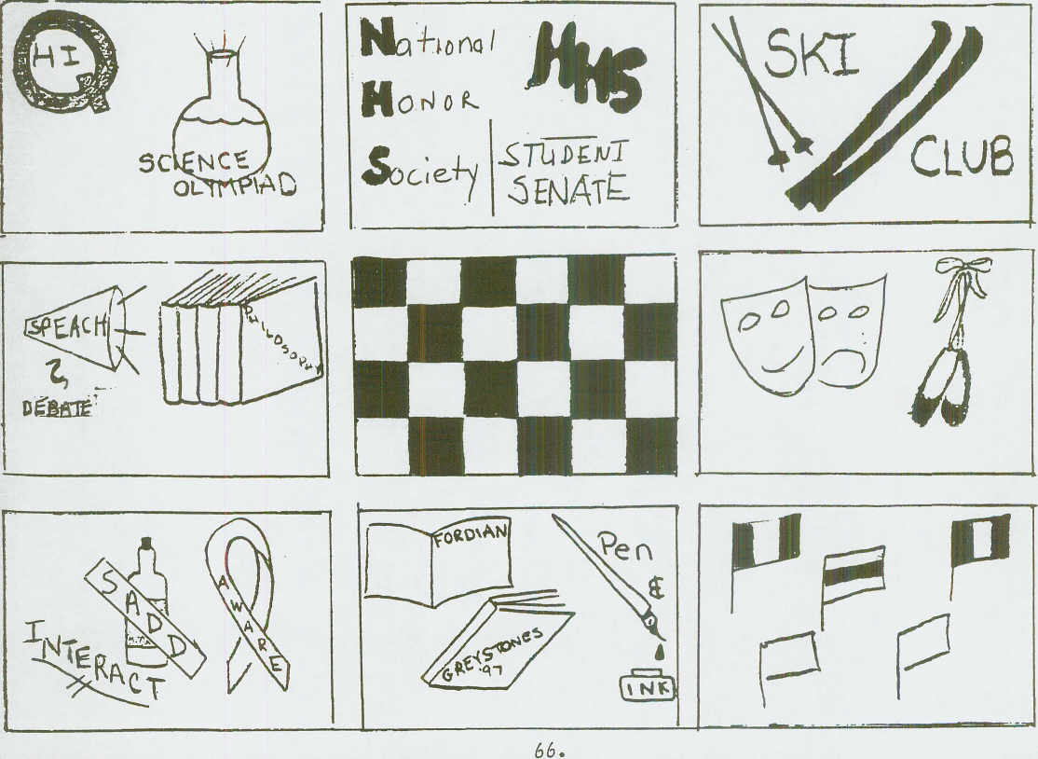

Athletic Awards
Students who represent Haverford Senior High School in interscholastic athletic contests have been recognized for many years through a program of awards presented by the Haverford High School Athletic Department. The following guidelines have been adopted as the basis for the awarding of varsity, junior varsity, and freshmen letters.
1. Any member of an athletic squad meeting the letter requirements set forth herein shall be awarded a letter if it is the first letter earned in that sport. Persons earning subsequent letters in the same sport will receive a certificate and pin. But should the athlete want to purchase a letter at cost, they may do so.
2. To qualify for an award, an athlete must finish their sport season in good standing. An athlete can be disciplined during a season and still finish the season in good standing, but participation missed due to disciplinary action cannot be credited toward earning an award.
3. Any student whose conduct or sportsmanship is in question by a faculty
member or coach may be considered not in good standing and subsequently may be barred from consideration for a letter.
4. An athlete missing playing time because of ineligibility due to academic or attendance deficiency may not receive credit for participation.
5. Students who legally transfer into the school district during an athletic season and participated on a Haverford team during that season will be credited for their participation at their previous school district under the guidelines set forth here.

Eligibility for athletic awards
Eligibility for athletic awards are determined through the degree of participation by the athlete in scheduled contests. Below is a list of minimum requirements for varsity letter eligibility. Junior varsity and freshmen letters will be awarded to all participants.
Athletics will only receive one letter per sport, additional years of play will be rewarded with a sport pin.
BOYS
Baseball Participate in 2/3 of scheduled games
Basketball Participate in 2/3 of scheduled games
Cross Country Participate in half the dual meets or place in districts or states
Football Participate in 2/3 of scheduled games
Ice Hockey Participate in 2/3 of scheduled games
Soccer Participate in 2/3 of scheduled games
Tennis Participate in 2/3 of scheduled matches
Track Score in more than half the dual meets; or score in a championship meet; or set a school record
Wrestling Participate in 2/3 of scheduled meets
Lacrosse Participate in 2/3 of scheduled games
Swimming Earn 8 points and participate in more than 1/2 of the meets. Relay points are divided among individuals swimmers.
Golf Participate in 2/3 of scheduled matches
Volleyball Participate in 2/3 of scheduled games

GIRLS
Basketball Participate in 2/3 of scheduled games; attend required practices
Cheerleaders Participate in 3/4 of scheduled games; attend required practices.
Cross Country Participate in 1/2 the dual meets or place in districts or states
Hockey Participate in 2/3 of scheduled games; attend required practices
Lacrosse Participate in 2/3 of scheduled games; attend required practices.
Soccer Participate in 2/3 of scheduled games; attend required practices.
Swimming Participate in 2/3 of scheduled games; attend required practices.
Tennis Participate in 2/3 of scheduled games; attend required practices.
Track Awarded based upon a point system
Volleyball Participate in 2/3 of scheduled games
Participation in a minimum of six interscholastic contests within a season are necessary before letters will be awarded for a sport. Participation involves playing for a period of time equal to 1/4 of the total playing time in a contest not just a token appearance in a contest for brief periods of time as a substitute. Each sports' managers will receive coaches' written recommendations. No more than two managers of any sport will be awarded letters.
Exceptions to any and all regulations listed above can be made upon the recommendation of the coach and approval of the Director of Athletics.
High School Programs
Season Start Dates
August 14 Nov. 17 March 5
FALL  *FOOTBALL – Freshman, JV& V  VOLLEYBALL – Freshman, JV & V  FIELD HOCKEY – JVB, JV & V  BOYS SOCCER – Freshman, JV & V  GIRLS SOCCER – JVB, JV & V  X-COUNTRY – Boys and Girls  GIRLS TENNIS – JV & V  GOLF – J & V Coed  CHEERLEADING –JV & V | WINTER  GIRLS BASKETBALL – Freshman,  JV & V Girls  BOYS BASKETBALL – Freshman,  JV & V  WRESTLING – JV & V  SWIMMING / DIVING – Boys & Girls  WINTER BOYS TRACK  WINTER GIRLS TRACK  CHEERLEADING –JV & V  ICE HOCKEY – Club Sport | SPRING  BASEBALL – Freshman, JV & V  SOFTBALL – JVB, JV & V  GIRLS TRACK  BOYS TRACK  GIRLS LACROSSE – JVB, JV & V  BOYS LACROSSE –JV & V, JVB  BOYS VOLLEYBALL – JV & V  BOYS TENNIS – JV & V
*Football – PIAA requires a 5 day heat acclimatization prior to the schedule start date. Players will be asked to report August 7/21(FrFB) to begin the acclimatization period
Levels of Competition
Freshman: Following the Haverford High School philosophy, an attempt is made to maximize the level of participation. Eliminations are determined at the discretion of the coaches. Team members are selected at the coaches' discretion. Eliminations may be made. The freshman teams are the only high school teams where membership is exclusive to one grade.
Junior Varsity & JVB: Junior Varsity teams are more competitive than freshman teams, and students in grades 9 through 12 may participate. JV is viewed as the building block of Varsity and the selection of JV Players is focused to reflect who can best serve as a future Varsity Player. Seniors may be excluded from some teams. Eliminations are determined at the discretion of the coaches.
Varsity: Varsity, the highest level of competitive sports, is open to students in grades nine through 12. Eliminations are determined at the discretion of the coaches.
Each sports' head coach is in charge of that sport. The assistant, JV, and freshman coaches work under the direction of the head coach. All coaches are supervised by the athletics/activities director and the high school principal. As a member of the Central Athletic League and the Pennsylvania Interscholastic Athletic Association (P.I.A.A.), varsity teams may qualify for league, sectional, district, regional, and state tournaments.
All athletes involved in interscholastic athletics shall participate in their usual physical education classes held during the regular school day.

Uniforms and Equipment
It is the responsibility of each student/athlete to return any and all uniforms and equipment at the end of the season. If student/athletes fail to do so, appropriate disciplinary action will be taken.
A grade level obligation will be a placed in the student’s name for the dollar value of the unreturned equipment. Report cards will be held until all obligation assigned to a student are cleared with their grade level office.

Booster Clubs

Parent Booster Clubs are organizations that are established to support teams. They are not mandatory for student participation. Booster Clubs provide fund raising for banquets and team related community events. Any dues or required contributions are independent of the District and not a requirement with regard to student participation. Booster Clubs should have by-laws that are the governing rules of their organization. The District will at the end of the season request an accounting of the Booster Clubs Funds for required disclosure.

Baseball ~ Boys

Baseball should be fun. Team members will show a dedication to Haverford baseball, sportsmanship, academic eligibility, and to the team concept as well as wearing the Haverford uniform with pride. Team members learn fundamentals, a team attitude, and good sportsmanship. JV and Freshman will develop and refine skills necessary to become a Varsity caliber athlete.

Level: Varsity, Junior Varsity, Freshman

Eligibility: Tryouts – approx 75 try-out, 45 members make the teams
School District and PIAA eligibility requirements

Coach/Sponsor: Varsity: Paul Bogosian
JV: Dave Detweiler
Freshman: James Coyne

Schedule/Meeting Place: Practice: Gym/Field
Freshman: Game Lynnewood Elementary
Games: Varsity and JV - High School Field
Spring: Practice and Game After School, 2:30 to 7:00 pm

Transportation: School Bus

Parent Involvement: Booster Fund raising – hoagie sale, holiday caramel popcorn sale
Attendance at Games, positive reinforcement

Basketball ~ Boys
The students will learn the finer points of basketball in a highly competitive environment. Players will be expected to attend all practices and games unless specifically excused. Discipline and hard work are expected as is a commitment to overall excellence.
Level: Varsity, Junior Varsity, Freshman
Eligibility: Tryouts - PIAA eligibility requirements
Sponsor/Coach: Varsity: Keith Heinerichs JV: Peter Phillips Freshman: Leon Smith
Schedule/Meeting Place: HHS gym
Varsity and JV practice/games will take place in the evening and on occasion in the afternoon.
Freshman: Practice and games in the afternoon
Transportation: School bus
Parent Involvement: Fund raising; game support
Alternatives to Activity: Team manager or statistician

Basketball ~ Girls
The students will learn the finer points of basketball in a highly competitive environment. Players will be expected to attend all practices and games unless specifically excused. Discipline and hard work are expected as is a commitment to overall excellence.
Level: Varsity, Junior Varsity, Freshman
Eligibility: Tryouts - PIAA eligibility requirements
Sponsor/Coach Varsity: Lauren Pellicane Junior Varsity: Katie Young Freshman: Nancy McGoldrick
Schedule/Meeting Place: HHS gym
Varsity and JV: Practice, late afternoon/early evening and games, evening with a few in afternoon. Freshman: Practice and games in the afternoon
Transportation: School bus
Parent Involvement: Fund raising and team support
Alternatives to Activity: Team manager or statistician; ninth grade team

Cheerleading
The goal is to accelerate school spirit and sportsmanship while developing strong mental and physical athletes. The Cheerleading team also takes pride in competing in high level competitions.
Level: Varsity, JV and Freshman
Eligibility: School District and PIAA eligibility
Sponsor/Coach: Varsity: Maria DiPaul Safern JV: Joanna Turner Kelly
Cost: Between $200-$300- Team attends gymnastics lessons in addition to scheduled practice
Schedule/Meeting Place: HS East Commons
Mid August -March
Transportation: School bus or van
Parent Involvement: Fund raising and support Rogers
Special Information: Summer camp - both squads.
Regional competition - varsity
Nationals - varsity
Central League competition

Cross Country ~ Boys and Girls
The team will learn about the sport, how to compete, and how to win or lose. Members will receive proper training and belong to a team. The team will run, have fun, get in shape and win. Members are expected to follow team and school rules and make a commitment to excellence.
Levels: All, no cuts
Eligibility: Open – School District and PIAA eligibility requirements
Sponsor/Coach: Boys – Harry Green Girls—Laura Clinton Assistant Elizabeth
Haglund
Cost: Racing flats and training shoes
Schedule/Meeting Place: Playing fields. Fall, daily after school.
Saturday meets at schools and parks. Transportation: School bus

Parent Involvement: Booster Club and meets

Field Hockey ~ Girls
Students will learn and understand the game of field hockey and develop team and individual skills necessary to play at a highly competitive level. Commitment to the team and program is expected.
Level: Varsity, Junior Varsity, Freshman
Cost: Stick and field shoes
Eligibility: Tryouts held last two weeks in August;
PIAA eligibility requirements
Coach/Sponsor: Varsity: Christa Taylor
JV: Polly Ross
JVB: TBA
Schedule/Meeting Place: Fall, daily after school; schedule to be posted.
Varsity /JV–Haverford Community Park JVB High School Field
Transportation: School bus
Parent Involvement: Fund raising; support games
Alternative to Activity: Team manager, statistician, ninth grade team
Special Information: Pre-season (the last two full weeks in August) is
designated as mandatory for those entering 10th-12th
grade. It is option for those entering ninth grade and electing to play on the JVB Team.

Football
Focus will be on the development of fundamental football skills and team concept. Participation in the BFS strength and conditioning program is expected.
Level: Varsity, Junior Varsity, Freshman
Eligibility: Open, no cuts; School District, PIAA eligibility requirements Sponsor/Coach: Varsity: Joe Gallagher
JV: Scott Lipschutz
Freshman: Elliot Seifert
Cost: Football shoes, physical
Schedule/Meeting Place: Summer camp: 8:00 a.m. - 5:00 p.m. two weeks at school.
After school: 2:45 - 6:00 p.m., at school. Transportation: School bus
Parent Involvement: Fund raising and support at games.
Parent Contact: Football Followers
Alternative to Activity: Team manager

Golf
An opportunity for as many candidates as possible to participate in a life-long sport and activity. Students will learn proper on and off course etiquette and good sportsmanship. Although this is primarily an individual sport, team spirit goals are nurtured and encouraged.
Level: Varsity
Eligibility: Tryouts - PIAA eligibility requirements
Sponsor/Coach: Varsity: Nate Oxman- Greg Decina

Cost: Golf shoes (metal or soft spikes), clubs, slacks
Schedule/Meeting Place: Home field & try-outs: Varsity: Merion West Golf Course-
Cobbs Creek
Tournament courses: Delaware & Montgomery Counties
Transportation: School van and District Busing
Parent Involvement: Transport clubs to course or school
Alternatives to Activity: Team manager or statistician

Ice Hockey-CLUB SPORT
Students will learn the game of ice hockey and develop team and individual skills in a highly competitive environment. Dedication to the team and hard work is expected. Effort and attitude is valued more than anything else.

Level:
Eligibility:
Sponsor/Coach:
Cost:
Schedule/Meeting Place:
Transportation:
Parent Involvement:
Alternatives to Activity:
Special Information:
Varsity (9th - 12th) and Junior Varsity (7^-12^ grade) Tryouts - PIAA eligibility requirements
Hockey Board Appointed- John Povey

Club cost $$$ plus equipment
1 night/week at the Skatium Home and some away games at the Skatium with the remainder of the games at area rinks.

Away games by school bus
Parent Board, Representatives to the Junior Varsity and Varsity leagues. Fund raising, year book and support at the games.
Team manager or statisticians
Ice Hockey is a club sport to District. Student who play are expected to follow all district rules relating to athletics. A hockey board is in place that govern the team bylaws.

Lacrosse ~ Boys
Team members will develop individual skills, team concepts and team camaraderie. Dedication and hard work is expected.
Level: Varsity, Junior Varsity, JVB
Eligibility: Varsity - Tryouts; JV & JVB- No tryouts
PIAA requirements
Sponsor/Coach: Varsity: Greg Decina Assistant: Michael Leyden
JV: Bryan Arra JVB: Jack O’Donnell
Cost: Cleats: $30-$50; Stick: $50-$60 Schedule/
Meeting Place: TBA.; AG Cornog Transportation: School bus
Parent Involvement: Booster Club; fund raising
Alternatives to Activity: Team manager
Lacrosse ~ Girls
Students will learn the game of lacrosse, how to get along with many people, and school work comes before anything. Dedication and hard work is expected. Sportsmanship and pride at Haverford are a must.
Level: Varsity, Junior Varsity, JVB
Eligibility: Tryout –School District and PIAA eligibility requirements Sponsor/Coach: Varsity: Nancy McGoldrick Assistant Kirstin McGoldrick-Sheehe
JV: Jessica McClay
JVB: Natalie Rube
Cost: Cleats: $25-$45; Stick: $35-$70
Schedule/Meeting Place: JVB Williamson Field (Manoa Field)/ V-JV AG Cornog
Transportation: School bus
Alternatives to activity: Team manager, statistician
Special Information: Two scrimmages; 18 games, several night games

Soccer - Boys
Learn and play the game of soccer with a commitment to the sport and the
classroom. Dedication to practices and games along with good behavior and
sportsmanship are expected at all times.

Level:
Eligibility:
Sponsor/Coach:
Cost:
Schedule/Meeting Place:

Transportation:
Parent Involvement:
Alternatives to Activity:
Special Information:
Varsity/ Junior Varsity and Freshman
Tryouts - PIAA eligibility requirements
Varsity: David Cassanelli
JV: Andrew Welsh
Freshman: Iain McClements
Cleats; Shin guards
Fall, everyday after school/evenings/Fr. Coopertown
JV & V Turf field following schedule
School bus
Booster Club
Team manager, statistician
Preseason camp starts August 11th

Soccer ~ Girls
Develop team and individual skills in a highly competitive setting. School work a first priority. Dedication and hard work are expected. Sportsmanship and pride are a must.
Level: Varsity and Junior Varsity
Eligibility: PIAA eligibility requirements
Sponsor/Coach: Varsity: Alexandra Hill , JV- Nancy McGoldrick, JVB: TBA
Cost: Cleats: $25-$45
Schedule/Meeting Place: After school and evenings- turf schedule
JV & V Turf Field/ JVB Williamson-Manoa lem.
Transportation: School bus
Parent Involvement: Fund raising; positive support at games
Alternatives to Activity: Team Manager, statistician
Special Information: Two scrimmages; twenty game schedule, several
night games

Softball - Girls
High School softball is played very competitively. Cooperation is an absolute must. Dedication to the team is required. Players should look at practices and games as learning activities.
Level: Varsity, Junior Varsity, JVB
Eligibility: Tryout, usually with cuts; School District and PIAA eligibility requirements
Sponsor/Coach: Varsity: Jill Marshall
JV: TBA
JVB: TBA
Cost: Rubber spikes, bat glove provided by players
Schedule/Meeting Place: Practice and games—Coopertown/ Reserve Elementary School Transportation: School bus
Parent Involvement: Fund raising; support at games
Alternatives to Activity: Team manager, statistician
Special Information: Most varsity players now play competitively year round.

Swimming & Diving
The sport of swimming is fun yet it is a sport that takes strong training, concentration and dedication. To learn good sportsmanship with intensity is something you will carry with you for the rest of your life.
Level: Varsity- Co-ed
Eligibility: School District and PIAA eligibility requirements
Sponsor/Coach: Matt Stewart Diving: Natalie Rube Assistant- Pat Maguire
Cost: Team swim suit
Schedule/Meeting Place: Practice site is the Haverford School.
Meets are on weekdays and some weekends
Transportation: You must find your own transportation to practice.
Bus provided for all meets.
Parent Involvement: Fund raising
Alternatives to Activity: Team manager

Track - Boys
The goal of this team is that all members of the team will practice and compete with the intent to get better performances. This should lead to the improvement of the individual athlete which will in turn improve the team.
Level: Varsity, Junior Varsity
Eligibility; Open –School District and PIAA eligibility requirements
Sponsor/Coach: Varsity:Aaron Hunter -Assistants Josh Fidler Jim Jeffers

Schedule/Meeting Place: HHS track; spring, daily after school, 2:45-5:15 p.m.
Transportation: School bus
Involvement: Support at meets.

Track ~ Girls
"Luck is a matter of preparation meeting opportunity" is the theme for Track & Field. Students will learn how to safely and efficiently train for running, hurdles, and field events. The focus is team enthusiasm and personal goals.
Level: Varsity, Junior Varsity
Sponsor/Coach: Head Coach: Jim Jenson –Assistants Harry Green, Jay Williams
Eligibility; Open –School District and PIAA eligibility requirements
Schedule/Meeting Place: HHS track; spring, daily after school, 2:45-5:15 p.m.
Transportation: School bus
Involvement: Support at meets.

Tennis - Boys
An opportunity for everyone to play/ learn and compete in the game of tennis. To learn to enjoy the game during the school year with teammates and to learn for a life sport. Members will grow and improve to try to be the very best they can. Look for instruction and practice outside of school and during the off season.

Level:
Eligibility:
Sponsor/Coach:
Schedule/Meeting Place:
Parent Involvement:
Special Information:

COST:
Varsity and JV
Tryouts – School District and PIAA eligibility requirements;
Play is according to a ladder system- Charles Withers
TBA
HHS tennis courts; Spring, after school each day.
Practice between 3-5 Team members expected to be at every practice and match

Booster Club and support match play
The Central League is know as one of the most competitive leagues in the state.
Racket and shoes

Tennis ~ Girls
Students will learn the fundamentals of tennis, develop their technical skills as well as their interpersonal skills as a member of the tennis team. Commitment to attend and to participate in all practices and to show support at all team matches.

Level:
Eligibility:
Sponsor/Coach:
Cost:
Schedule/Meeting Place:
Transportation:
Parent Involvement:
Alternatives to Activity:
Varsity and JV
Tryouts School District and PIAA eligibility requirements
Varsity: Charles Withers
JV: Kathryn Lisansky
Racket and shoes
Meet at high school; August-November.
Practices: 3-5:30 p.m.
Matches: home, 3-6 pm.; away, 3-7 pm (travel time)
School bus
Fund raising; support at matches
Team manager or statistician

Special Information: The Central League is know as one of the most competitive leagues in the
state

Volleyball ~ Boys
To learn the sport as a team member and play to your best ability.
Level: Varsity, Junior Varsity
Eligibility: District and PIAA eligibility requirements

Sponsor/Coach; Varsity: Sam Moyerman JV: David Dager
Cost:
Schedule/Meeting Place: Spring - March to May; practice five times a week, late afternoon; games in afternoon with a few at night. Approximately 15 games and 2 tournaments
Transportation: School bus
Parent Involvement: Booster Club
Volleyball - Girls
This is a teaching sport. The goal is to improve the skill level of each player and mold them into a special unit called "that team from Haverford." Members get in good physical condition and learn the game of volleyball.
Level: Varsity, Junior Varsity, Freshman
Eligibility: Tryouts - cuts only due to large numbers
District and PIAA eligibility requirements

Sponsor/Coach: Varsity: Eric Dahl JV Natalie Rube
Freshman: Kathy Leyden
Cost: Minimal - $20 for shoes
Schedule/Meeting Place: HS Gym
Fall-Mid-August to October;
Week day Practice/games-Sat. Tournaments
Transportation: School bus
Parent Involvement: Attend matches
Booster Club

Wrestling
Dan Gable, a very storied and respected Olympic wrestler and coach once said, "More enduringly than any other sport, wrestling teaches self control and pride. Some have wrestled without great skill; none have wrestled without pride." Pride for self, team, and school will be achieved through the rigorous but nurturing discipline of HAVERFORD WRESTLING. Wrestler will realize success is failure turned inside out and pride and perseverance will make winners of all involved.

Level:
Eligibility:
Sponsor/Coach:
Cost:
Schedule/Meeting Place:
Transportation:
:
Varsity, Junior Varsity
Open; School District and PIAA eligibility requirements
Head Coach: Shawn Fausey
Assistant Coach: James Knapp, TBA
Wrestling Shoes: $35-$110, according to name/style
HHS wrestling room
School bus and van
Score keeping, manager

High School Programs

FALL SPORTS
Boys Golf- Co-ed Girls

Soccer (F, JV, V) Soccer (JVB, JV, V)
Cross Country Cross Country
Cheerleading
Football (F, JV, V) Field Hockey (JVB, JV, V)
Volleyball (F,JV,V)
WINTER SPORTS Tennis

Boys Girls

Basketball (F, JV, V) Basketball (F, JV, V)
Ice Hockey (JV, V) Cheerleading (JV, V)
Indoor Track Indoor Track
Swimming & Diving Swimming & Diving
Wrestling (JV, V)

SPRING SPORTS
Boys Co-ed Crew Girls
Sponsorship along
Baseball (F, JV, V) with a boat club Lacrosse (JVB, JV, V)
Lacrosse (JVB, JV, V) membership Softball (JVB, JV, V)
Tennis (JV, V) Track
Track
Volleyball (JV, V)
Levels of Competition
Freshman: Following the Haverford High School philosophy, an attempt is made to maximize the level of participation. Eliminations are determined at the discretion of the coaches. Team members are selected at the coaches' discretion. Eliminations may be made. The freshman teams are the only high school teams where membership is exclusive to one grade.
Junior Varsity & JVB: Junior Varsity teams are more competitive than freshman teams, and students in grades 9 through 12 may participate. Seniors may be excluded from some teams. Eliminations are determined at the discretion of the coaches.
Varsity: Varsity, the highest level of competitive sports, is open to students in grades nine through 12. Eliminations are determined at the discretion of the coaches.
Each sports' head coach is in charge of that sport. The assistant, JV, and freshman coaches work under the direction of the head coach. All coaches are supervised by the athletics/activities director and the high school principal. As a member of the Central Athletic League and the Pennsylvania Interscholastic Athletic Association (P.I.A.A.), varsity teams may qualify for league, sectional, district, regional, and state tournaments.
All athletes involved in interscholastic athletics shall participate in their usual physical education classes held during the regular school day.

HAVERFORD SENIOR HIGH SCHOOL FUND RAISING REQUEST FORM
TO:
Director of Athletics/Activities
.plans to raise funds.
Activity. Class, Club. Organization, Team
(1) The date of the fund raising is
12) How are you going to raise the money?.
(3) What are you going to use the money for?
(4) How much are you trying to raise (dollar figure)?

Signature Sponsor/Coach Date

Administrators Approval _______________________
Director of Athletics/Activities

Principal Date.

